SIMATS ENGINEERING (SAVEETHA SCHOOL OF ENGINEERING)
Department of Computer Science and Engineering

ASSESSMENT TOOL 2 – CONCEPT MAPPING

Course Code: | CSA06 | Course Title: | Design and Analysis of Algorithms
CO Assessed: | CO1 – Precision (BL1, BL2, BL3) | Assessment: | Assessment Tool 2 – Concept Mapping
Weightage: | 20% of CIA | Total Marks: | 100
CO1 Statement: | Determine algorithm efficiency using asymptotic notations and mathematical techniques including Master Theorem and substitution method. (BL1, BL2, BL3)
Student Name: | C.Manogna sri hasitha | Reg. No.: | 192525215
Section / Batch: | B. Tech-AI&ML | Date: | 16-07-2026

Instructions to Students
- Answer the following question. Total Marks: 100.
- Draw a clear and neat concept map for each question.
- Identify all key concepts and arrange them in a logical hierarchy.
- Show meaningful linkages between concepts using arrows and connecting words.
- Compare related concepts wherever required and justify the relationships clearly.
- Ensure the concept map is well-organized, readable, and properly labelled.

Question Type | Focus Area | Questions
Concept Mapping | Map algorithm efficiency concepts using asymptotic analysis, search techniques, recurrence relations, and recursion tree method | Q1

SECTION A – CONCEPT MAPPING

Code of Conduct
I __C.Manogna sri hasitha________________________ (Name / Reg No) certify that this submission is my original work and that I have adhered to the guidelines specified for this assessment. I understand that any violation of academic integrity rules will result in disciplinary action.
Signature of the Student: __C.Manogna sri hasitha_______________________

RUBRICS FOR CALCULATION

Criteria | Weigh tage | Level 4 – Exemplary | Level 3 –  Proficient | Level 2 –  Developing | Level 1 –  Beginning
Concept  Identification | 25% | Identifies all key concepts from literature accurately and comprehensively | Identifies most key concepts with minor omissions | Identifies limited concepts; some are irrelevant or missing | Fails to identify essential concepts
Linkages | 25% | Establishes clear, meaningful, and accurate relationships between concepts | Shows correct relationships with minor gaps | Relationships are weak, unclear, or partially incorrect | No meaningful relationships established
Organization | 20% | Concepts are wellstructured hierarchically with logical flow and grouping | Mostly organized with minor structural issues | Some organization but lacks clear hierarchy | No logical organization or structure
Integration of Literature | 20% | Integrates multiple studies effectively to show connections and comparisons | Shows some integration of literature | Limited integration; mostly isolated concepts | No integration  of literature evidence
Clarity | 10% | Concept map is clear, neat, visually structured, and easy to interpret | Generally clear with minor readability issues | Clarity is reduced; difficult to interpret in parts | Poorly presented and hard to understand

Marks Evaluation:
Criteria | Wt. | Level 4 –  Exemplary | Level 3 –  Proficient | Level 2 –  Developing | Level 1 –  Beginning
Concept Identification | 25%
Linkages | 25%
Organization | 20%
Integration of Literature | 20%
Clarity | 10%
Total Marks (100):

Faculty In-charge | Course Coordinator | Head of Department
Name: | Name: | Name:
Signature: _______________ | Signature: _______________ | Signature: _______________
Date: ___________________ | Date: ___________________ | Date: ___________________

Q1 . Explain how repeated halving reduces problem size efficiently. Extend the map by including sorted input requirement. Justify why logarithmic complexity is preferable. Interpret how this mapping supports efficient search algorithms.

Efficient Search Using Divide-and-Conquer: Understanding Repeated Halving and Logarithmic Complexity

Introduction
Searching for information is one of the most common tasks in computer science. Whether searching for a student's record in a database, locating a product in an online shopping website, or finding a book in a digital library, the efficiency of the search algorithm determines how quickly the result is obtained.
One of the most efficient searching techniques is Binary Search, which follows the Divide-and-Conquer strategy. Instead of checking every element one by one, Binary Search repeatedly divides the search space into two equal halves until the required element is found. This repeated halving greatly reduces the number of comparisons, making the algorithm significantly faster than linear searching.

1. Divide-and-Conquer Strategy
Divide-and-Conquer is an algorithmic technique that solves a problem by breaking it into smaller subproblems.
The strategy consists of three main stages:
Step 1 – Divide
The original problem is divided into two nearly equal parts.
Step 2 – Conquer
The algorithm determines which half may contain the required element and ignores the other half.
Step 3 – Combine
Since searching only needs one result, no merging is required. The algorithm continues searching in the remaining half until the target is found.
This strategy reduces unnecessary comparisons and improves execution speed.

2. How Repeated Halving Reduces Problem Size Efficiently
Repeated halving means that after every comparison, half of the remaining elements are discarded.
Suppose there are 16 sorted elements.
Step | Elements Remaining
Initial | 16
1st Comparison | 8
2nd Comparison | 4
3rd Comparison | 2
4th Comparison | 1
Instead of examining all 16 elements individually, Binary Search reaches the answer in only 4 comparisons.
For example:
Initial Array

[2][5][8][12][15][18][22][27][31][36][40][45][50][55][60][65]

↑
Middle = 27
If searching for 50
- Compare with 27
- Since 50 > 27, ignore the left half.
- Search only the right half.
- Again find the middle.
- Continue until 50 is located.
Each comparison cuts the search space into half, making the algorithm extremely efficient.

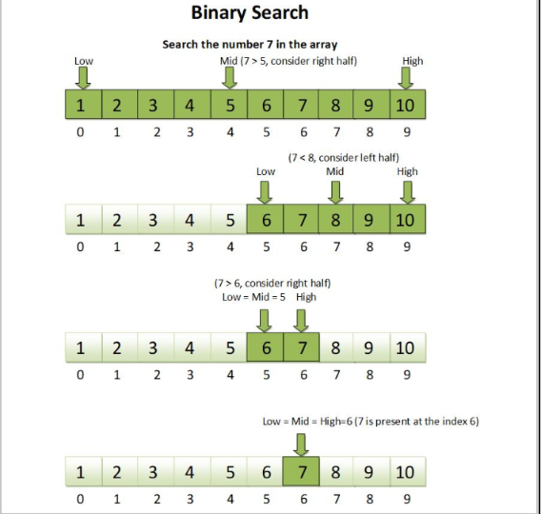

3. Extended Map Including Sorted Input Requirement
Binary Search works correctly only when the data is sorted.
Mapping of Binary Search Process
Start
│
▼
Input Data
│
▼
Is Data Sorted?
│
┌─┴────────────┐
│ │
No Yes
│ │
▼ ▼
Sort Data Find Middle Element
│ │
▼ ▼
Compare Target with Middle
│
┌──────┼───────────────┐
│ │ │
Equal Smaller Greater
│ │ │
▼ ▼ ▼
Found Search Left Search Right
Half Half
│
▼
Repeat Until Found
│
▼
End
The sorting step ensures that elements are arranged in ascending or descending order, allowing half of the data to be safely discarded after each comparison.
Without sorted input, Binary Search cannot determine which half should be searched next.

4. Why Sorted Input is Necessary

Consider the following unsorted list:
18 4 25 9 30 2 15
Searching for 15
The middle element does not indicate whether 15 lies on the left or right because the numbers are unordered.
Now sort the list.
2 4 9 15 18 25 30
The middle element becomes 15, allowing the algorithm to locate the target immediately.
Sorting provides a meaningful order that enables repeated halving.

5. Why Logarithmic Complexity is Preferable
Binary Search has a time complexity of
[
O(\log n)
]
This means that the number of comparisons increases very slowly even when the data size becomes very large.
Comparison
Number of Elements | Linear Search O(n) | Binary Search O(log₂ n)
16 | 16 comparisons | 4 comparisons
32 | 32 comparisons | 5 comparisons
64 | 64 comparisons | 6 comparisons
128 | 128 comparisons | 7 comparisons
1024 | 1024 comparisons | 10 comparisons
1,000,000 | 1,000,000 comparisons | About 20 comparisons
This comparison clearly shows that Binary Search remains efficient even for very large datasets.
Advantages of Logarithmic Complexity
- Requires very few comparisons.
- Handles large datasets efficiently.
- Reduces execution time.
- Improves system performance.
- Saves processing resources.
- Suitable for real-time applications.

6. How This Mapping Supports Efficient Search Algorithms
The Binary Search mapping demonstrates the systematic flow of the algorithm.
Efficient Workflow
Sorted Input
│
▼
Find Middle
│
▼
Compare Target
│
▼
Discard Half of Data
│
▼
Repeat Process
│
▼
Element Found
This workflow supports efficient searching because:
- The search area becomes smaller after every comparison.
- Unnecessary elements are ignored immediately.
- Fewer comparisons reduce computation time.
- Large databases can be searched quickly.
- Memory usage remains low since only a few variables are needed.
- The algorithm scales well as data size increases.

7. Real-World Applications
Binary Search is widely used in many real-life systems.
E-Library Search System
Books are arranged alphabetically. Binary Search quickly locates a required title.
Student Database
Student IDs are stored in sorted order, allowing rapid record retrieval.
Online Shopping
Products are sorted by price or name for faster searching.
Banking Systems
Customer account numbers are searched efficiently.
Hospital Information Systems
Patient records are retrieved quickly from sorted databases.
Digital Dictionaries
Words are stored alphabetically, making searches fast and efficient.

8. Time and Space Complexity
Time Complexity
- Best Case: O(1)
- Average Case: O(log n)
- Worst Case: O(log n)
Space Complexity
- Iterative Binary Search: O(1)
- Recursive Binary Search: O(log n)

Conclusion
Repeated halving is the foundation of the Divide-and-Conquer strategy used in Binary Search. By eliminating half of the remaining search space after every comparison, the algorithm dramatically reduces the number of operations required to locate a target element. This efficiency is possible only when the input data is sorted, enabling meaningful comparisons with the middle element. As a result, Binary Search achieves O(log n) time complexity, making it one of the most efficient search algorithms for large datasets. Its systematic mapping, minimal comparisons, and excellent scalability make it an ideal choice for applications such as digital libraries, banking systems, hospital databases, online shopping platforms, and many other real-world information retrieval systems.

